**Test Case 5**

**System:** Bench

**Description:** Test that the functionality of sending and receiving messages work.

**Severity:** 4

**Instructions**

**Test 1**

1. Start the Bench application.
2. Click the button “Login” on the navigation bar.
3. Enter the email “rachel.la2310@gmail.com” into the text field labeled “Email address”.
4. Enter the password “12345678” into the field labeled “Password”.
5. Click the button “Login” below the field.
6. After the screen has loaded, click on the button “Chat” on the navigation bar.
7. Click on any of the existing chat panels listed on the left sidebar.
8. Enter a text message in the input text field in the chat room between the current user and the selected user.
9. Click the send button on the right of the input field.

**Expected Result:** The text message you just sent should appear in the chat history on top of the input field in the chat room which indicates that you have successfully sent the message to the selected user.

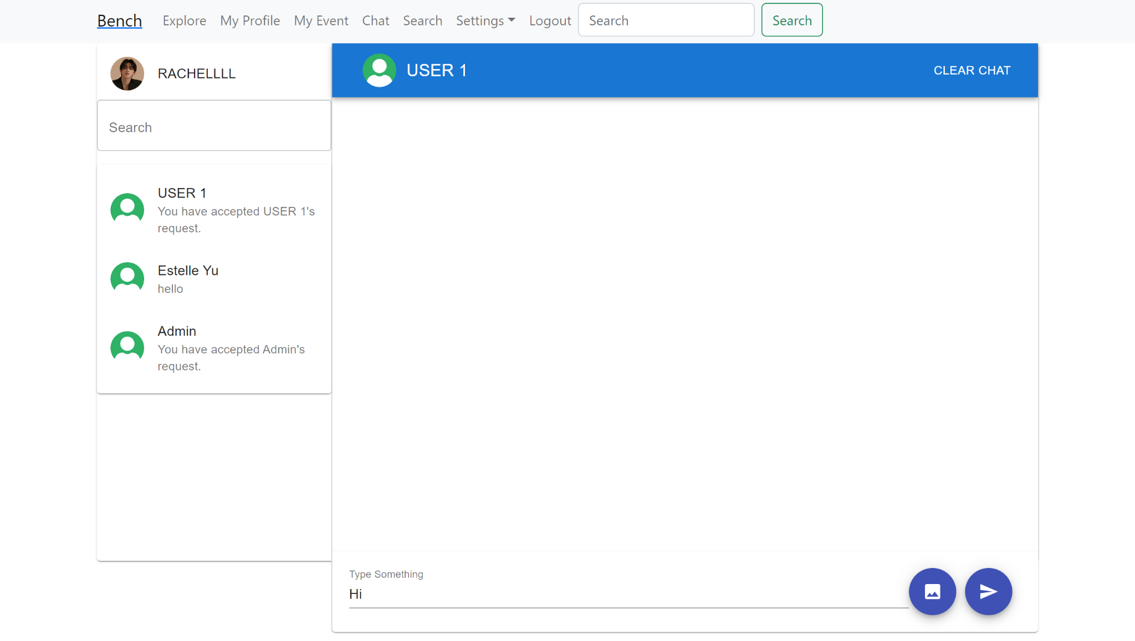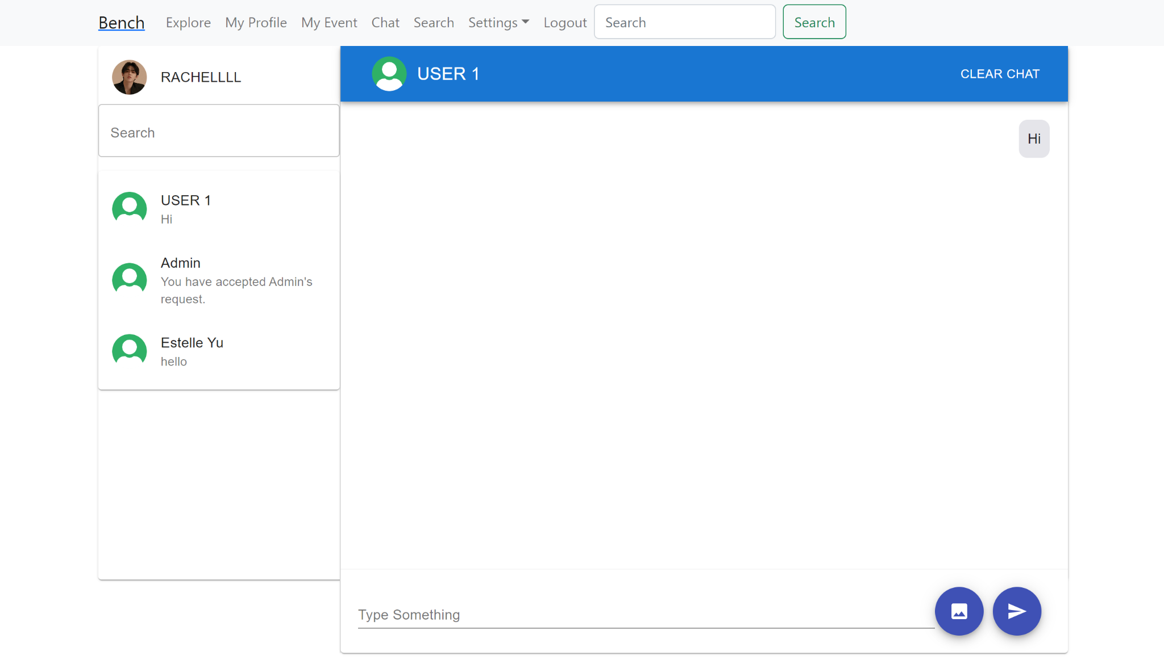

**Test 2**

1. Start the Bench application.
2. Click the button “Login” on the navigation bar.
3. Enter the email “rachel.la2310@gmail.com” into the text field labeled “Email address”.
4. Enter the password “12345678” into the field labeled “Password”.
5. Click the button “Login” below the field.
6. After the screen has loaded, click on the button “Chat” on the navigation bar.
7. Click on any of the existing chat panels listed on the left sidebar.

**Expected Result:** If the other user has sent you any messages before, the messages they sent you should appear on the chat history in the chat room between you two on your site.

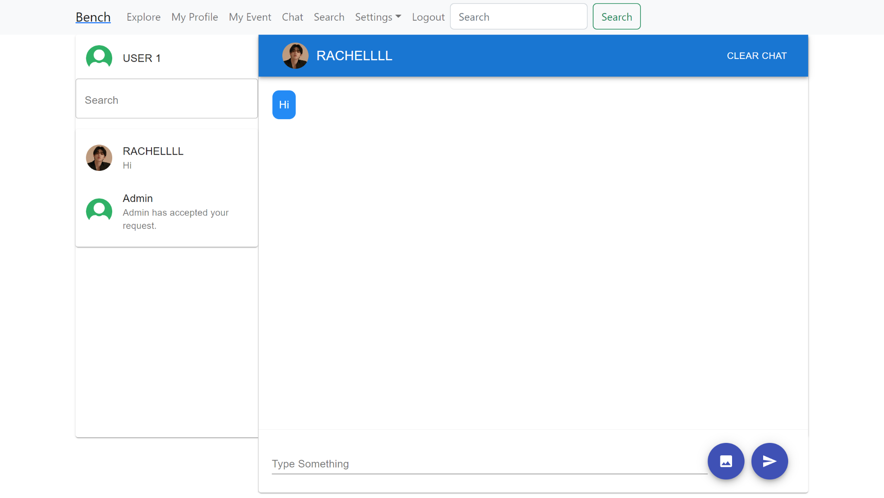

**Test 3**

1. On device “A”, Start the Bench application.
2. Click the button “Login” on the navigation bar.
3. Enter the email “rachel.la2310@gmail.com” into the text field labeled “Email address” to login as user Rachellll.
4. Enter the password “12345678” into the field labeled “Password”.
5. Click the button “Login” below the field.
6. After the screen has loaded, After the screen has loaded, click on the button “Chat” on the navigation bar.
7. Click on the existing chat panel labeled with the user “USER1” to enter the chat room between the user user1 and the current user, Rachellll.
8. On a different device which we call “B”, start the Bench application.
9. Click the button “Login” on the navigation bar.
10. Enter the email “user1@gmail.com” into the text field labeled “Email address” to login as user user1.
11. Enter the password “12345678” into the field labeled “Password”.
12. Click the button “Login” below the field.
13. After the screen has loaded, After the screen has loaded, click on the button “Chat” on the navigation bar.
14. Click on the existing chat panel labeled with the user “RACHELLLL” to enter the chat room between the user Rachellll and the current user, user1.
15. On device “A”, send a message from account Rachellll to user1 by typing a message in the input field and clicking the send button.
16. On device “B”, check if the account user1 receives the specific message immediately by checking if this specific message appears in the chat room history between user1 and Rachellll.
17. Do it in reverse by sending a message from device “B” to device “A”, and check if the messaging functionality works immediately.

**Expected Result:** The messages sent to the other user should be received by the other user immediately.

